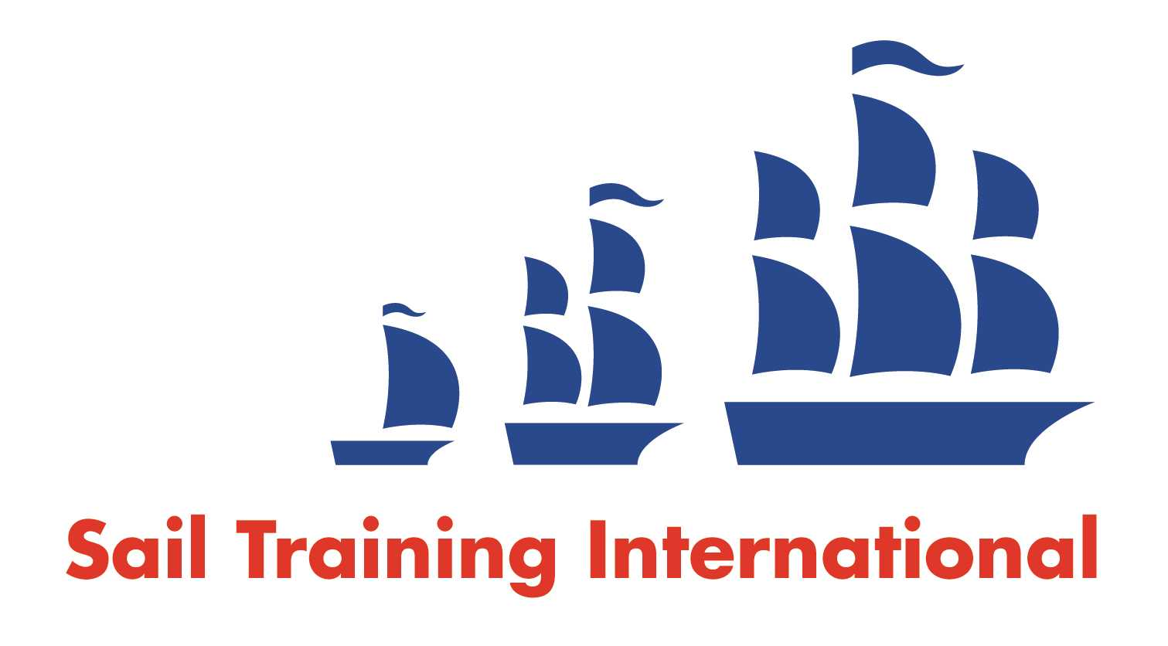
Sail Training International Paid/Volunteer Positions Submission Form

Editorial Policy

- This listing facility is free of charge but will only be accepted from sail training organisations and vessel operators that are members of their national sail training organisation or the Sail Training International Class A Tall Ships Forum.

- STI reserves the right not to publish a listing for any reason whatsoever.

- After completing the form, email to STI (office@sailtraininginternational.org) with copy to your National Sail Training Organisation for editorial review and approval prior to publishing on site.

Date of Posting | 13/07/2020
Name of Vessel | Ocean Spirit of Moray
Organisation Recruiting | Gordonstoun School
Name of Position | Second Mate
Location of Position | Scotland West Coast
Position is |  |  | Seasonal | X
Remuneration | Paid  (delete as appropriate) | On Application (delete as appropriate)
Description of Position | Female Second Mate on board Ocean Spirit of Moray  salary £15,000.00 p/a (pro rata for contract period).  Gordonstoun is seeking dynamic and self-motivated female Sail Trainers to be part of the professional team aboard our 80 foot Sail Training Ketch Ocean Spirit of Moray  for the 2020 sailing season. Employment will be on a fixed term basis from mid-August 2020 to November 2020 with dates to be confirmed at interview.  Candidates should hold RYA Day Skipper/Watch Leader certificate or above, and an excellent track record of working in positions of responsibility on board Sail Training vessels over 20 meters.  In line with the occupational requirements of the Equality Act 2010, only female applicants over the age of 21 can apply for this role.
Person to Contact | recruitment@gordonstoun.org.uk
Organisation’s website: | www.gordonstoun.org.uk
Email | recruitment@gordonstoun.org.uk
Telephone | 01343 837916.
Fax
Closing Date for applications | 27th July 2020.

