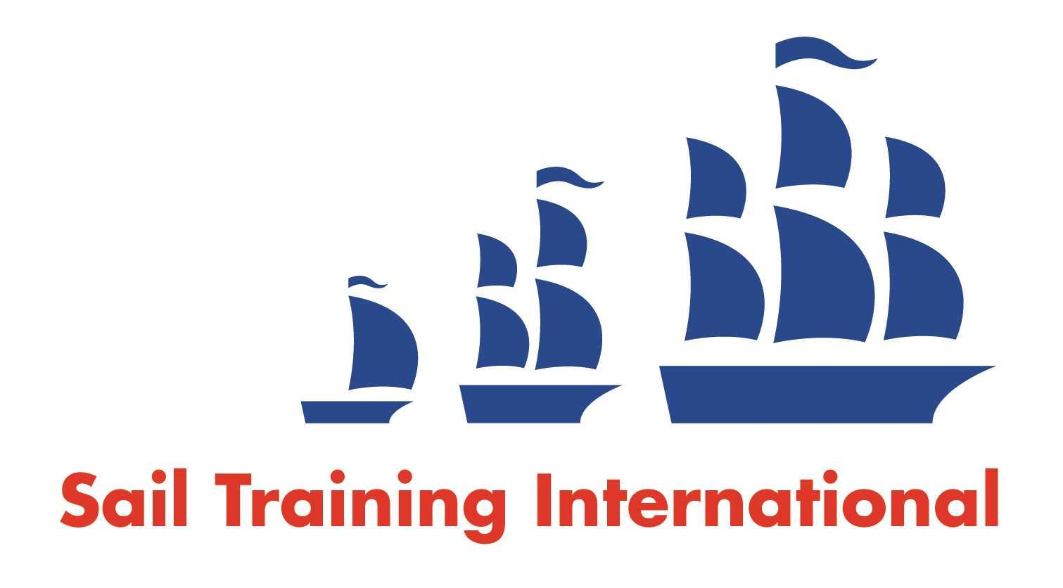
Sail Training International Positions Sought Submission Form

Editorial Policy

- This listing facility is open to any vessel operator or organisation involved in sail training.

- STI reserves the right not to publish a listing for any reason whatsoever.

- After completing the form, email to STI (office@sailtraininginternational.org() for editorial review prior to publishing on site. You can expect your advertisement to appear within 2-3 business days.

- Your listing will be automatically removed after three months unless you indicate an earlier date. To retain a listing beyond three months, please notify STI before the end of the three month period.

Date of Posting | 20/03/2020
Name | Charlotte Cumberbirch
Position Sought | Cook
Location preference | Worldwide
Full Time |  | Paid
Description of Position Sought  (max 100 words) | Looking for a full time position cooking for up to 30 pax as solo chef or more as part of a team.  3 years experience on tall ship catering for up to 24 pax including vegetarian, vegan, gluten free etc.. Able to work unsupervised and happy to take full responsibility for my position. Can work to tight budgets!
Qualifications | STCW 95 BST  MLC compliant Medical certificate  Food hygiene certificate Spain  Various culinary courses/workshops.  YM theory (practical due in October 2020)  RYA Dayskipper
Email | charlottecumberbirch@gmail.com
Telephone | 0034674444600

