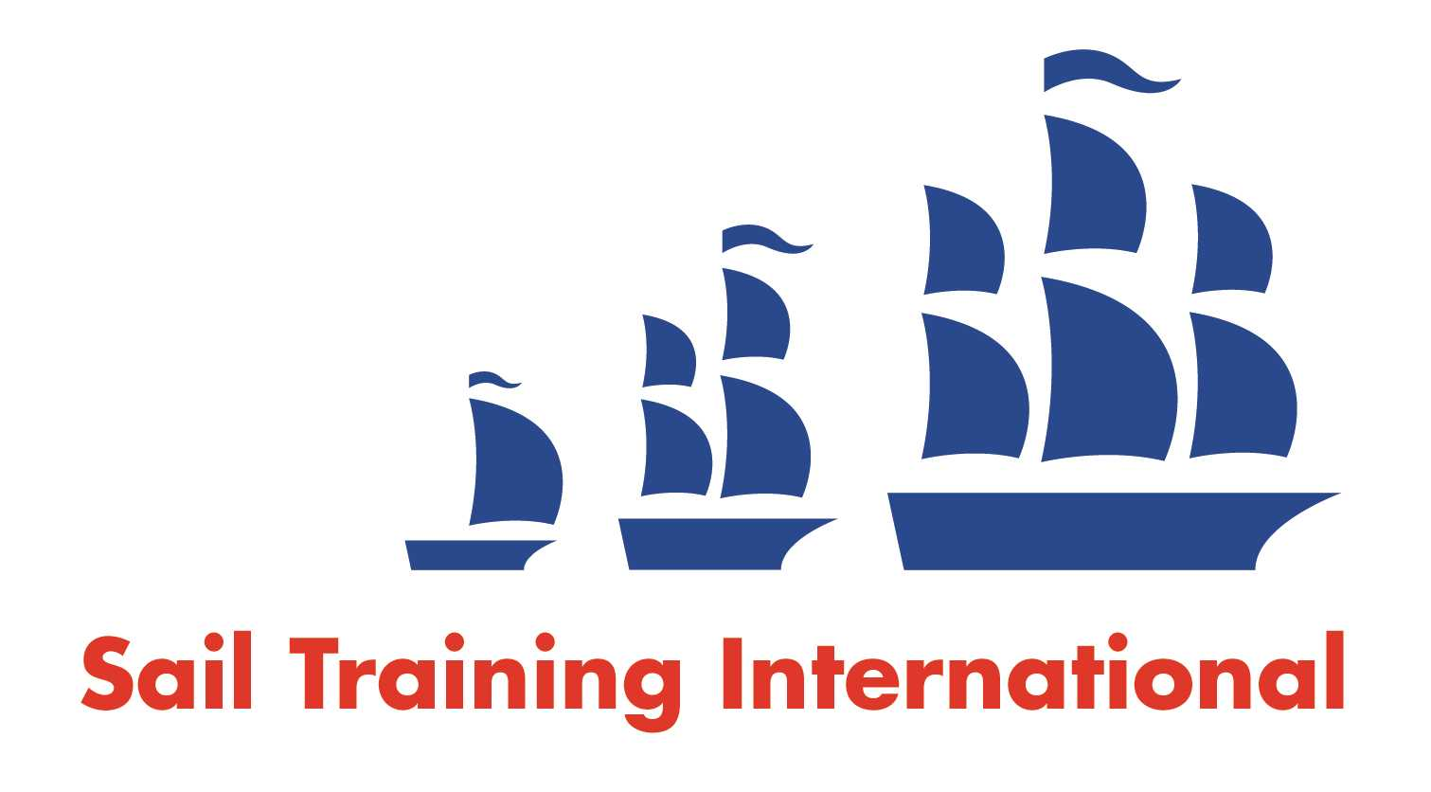
Sail Training International Paid/Volunteer Positions Submission Form

Editorial Policy

- This listing facility is free of charge but will only be accepted from sail training organisations and vessel operators that are members of their national sail training organisation or the Sail Training International Class A Tall Ships Forum.

- STI reserves the right not to publish a listing for any reason whatsoever.

- After completing the form, email to STI (office@sailtraininginternational.org) with copy to your National Sail Training Organisation for editorial review and approval prior to publishing on site.
Date of Posting | 2nd October 2019
Name of Vessel | TS Blue Clipper
Organisation Recruiting | Maybe Sailing
Name of Position | Engineer
Location of Position | On board TS Blue Clipper
Position is | Full Time | x | Rotational | X
Remuneration | Paid | £Contact us to discuss pay rate
Description of Position | Maybe Sailing are looking to recruit an engineer on board TS Blue Clipper. This is for two fixed term contracts with the possibility of additional work thereafter.  STCW safety certificates, ENG1 or equivalent, minimum MEOL or higher required. Electrical skills would be a plus.  Contract 1. 1st December – 14th January.  Contract 2. 25th March – 20th May.  The above contracts will include an Atlantic Crossing
Person to Contact | Frankie Hartwell
Organisation’s website: | www.maybe-sailing.com
Email | info@maybe-sailing.com
Telephone | +44 1133919809
Closing Date for applications | When filled

