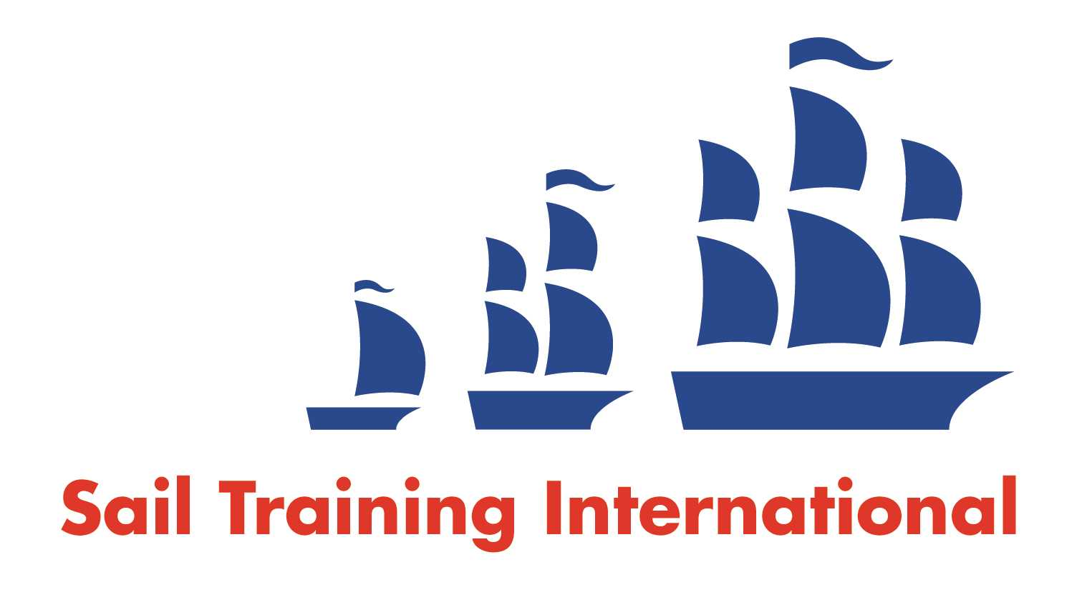
Sail Training International Positions Sought Submission Form

Editorial Policy

- This listing facility is open to any vessel operator or organisation involved in sail training.

- STI reserves the right not to publish a listing for any reason whatsoever.

- After completing the form, email to STI (office@sailtraininginternational.org) for editorial review prior to publishing on site. You can expect your advertisement to appear within 2-3 business days.

- Your listing will be automatically removed after three months unless you indicate an earlier date. To retain a listing beyond three months, please notify STI before the end of the three month period.

Date of Posting | 27/07/18
Name | Christopher Wren
Position Sought | Captain
Location preference | Worldwide
Full Time / Seasonal  (delete as appropriate) |  | Paid / Voluntary  (delete as appropriate)
Description of Position Sought  (max 100 words) | I am seeking a new position as captain of a sail-training vessel having completed 23 years experience in this field and sailed over a million miles mainly in the Mediterranean, Northern Europe and South Pacific.  I specialise in traditional rig vessels.  I also work voluntarily for registered charities.  http://sailtraining.chriswren.co.uk
Qualifications | Fully qualified as captain and also chief engineer.
Email | chris@chriswren.co.uk
Telephone | +44 7967 147603

