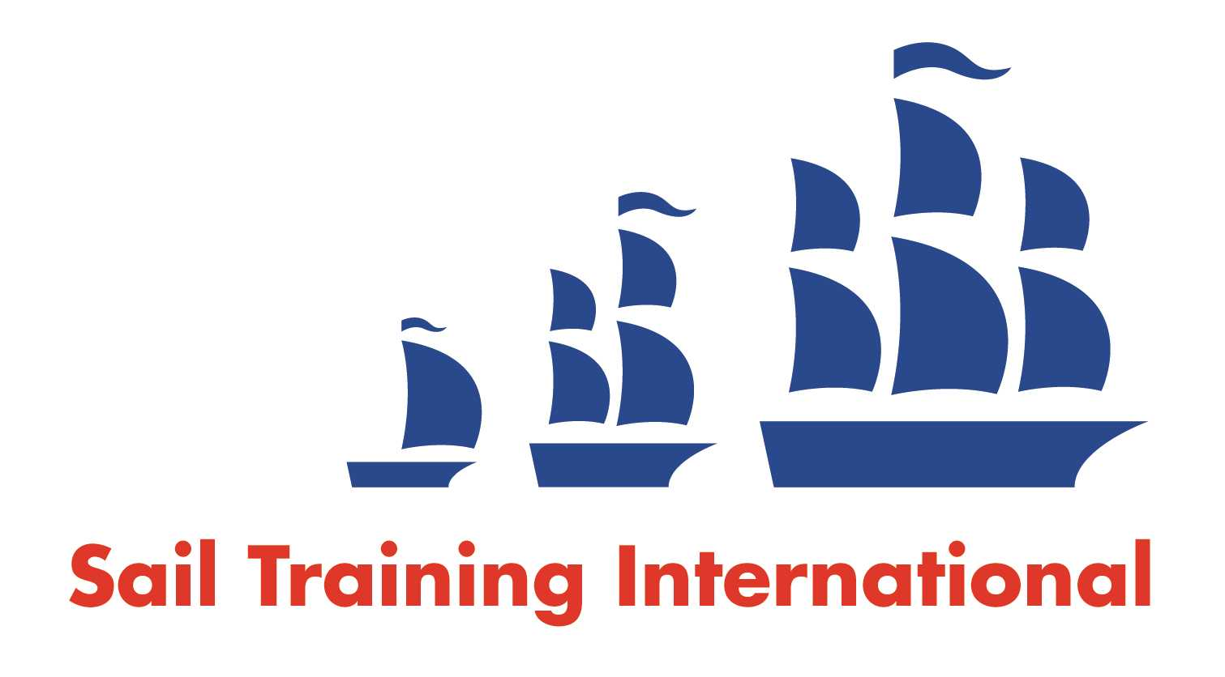
Sail Training International Paid/Volunteer Positions Submission Form

Editorial Policy

- This listing facility is free of charge but will only be accepted from sail training organisations and vessel operators that are members of their national sail training organisation or the Sail Training International Class A Tall Ships Forum.

- STI reserves the right not to publish a listing for any reason whatsoever.

- After completing the form, email to STI (office@sailtraininginternational.org) with copy to your National Sail Training Organisation for editorial review and approval prior to publishing on site.

Date of Posting | 24/05/2018
Name of Vessel | Various
Organisation Recruiting | Marine Society and Sea Cadets
Name of Position | Chief Instructor – Caledonia
Location of Position | Sea Cadet Training Centre Caledonia, Rosyth, KY11 2XH
Position is | Part Time |  | Permanent | X
Remuneration | Paid | £18,000 gross per annum
Description of Position | We are currently seeking an enthusiastic Instructor to deliver high quality training at our training facility in SCTC Caledonia which includes Port Edgar Boat Station.  This is position is full time for 6 months. Hours of work each week will be variable, but will average approximately 44 hours.  In this role you will responsible for the delivery of training, as directed by and in support of the Executive Officer and Chief Instructor.  You will be responsible for delivering training afloat and ashore to meet the centre’s training programme.  About you  You will be experienced at delivering fun and safe learning to young people and adults in an outdoor and classroom environment. Have a minimum of one of the following instructor qualifications; RYA Dinghy Instructor (Coastal), RYA Senior Instructor, RYA Start Windsurfing instructor, RYA Powerboat Instructor (Coastal) plus RYA Safety Boat (Coastal).  Knowledge of basic boat maintenance would be useful.  You will be motivated and enthusiastic in driving the training centre forward and developing a high quality service.  You will be passionate about instructing and want to put your skills into practice in our setting and as part of our team.  About us  The Marine Society & Sea Cadets (MSSC) is the nation’s largest maritime charity and the governing charity of the Sea Cadet Corps (SCC), a civilian voluntary youth organisation comprising some 400 or so volunteer Sea Cadet Units, throughout the UK.  The SCC offers a wide range of youth opportunities with the same enduring objective – to foster good citizenship in the community.  The centre is located within MoD CALEDONIA and the boat station is a short drive across the Forth Estuary, in Port Edgar Marina with boating taking place between the historic bridges. Windsurfing is taught in the picturesque location of Lochore Meadows Country Park.  The training centre is open for 50 weeks of the year and offers an interesting and diverse training plan. The main portion of this is for Cadet training (12 to 18 year olds).  The MSSC is committed to build a brand new training facility at Port Edgar starting this year.  The post can be demanding and working hours are as determined by the training programme, which will include evening and weekend working.  For an informal discussion about the role, please contact the training centre 01383 858326.  For more information on this post, please download the Job Description and Person Specification from our website at http://www.ms-sc.org/instructor-sctc-caledonia  Applications should consist of a completed application form, and the completed equal opportunities monitoring form, both available from the website. Please feel free to submit your CV in support of your application.  Please email applications to recruitment@ms-sc.org.  Closing date for applications: Midday, Wednesday 13th June 2016.  Successful applicants will be required to undergo a PVG Disclosure Scotland check.
Person to Contact | Simon Buckton-Holloway
Organisation’s website: | https://www.ms-sc.org/chief-instructor-caledonia
Email | recruitment@ms-sc.org
Telephone | 0207 654 7052
Fax | 0207 928 8914
Closing Date for applications | 13/07/2018

