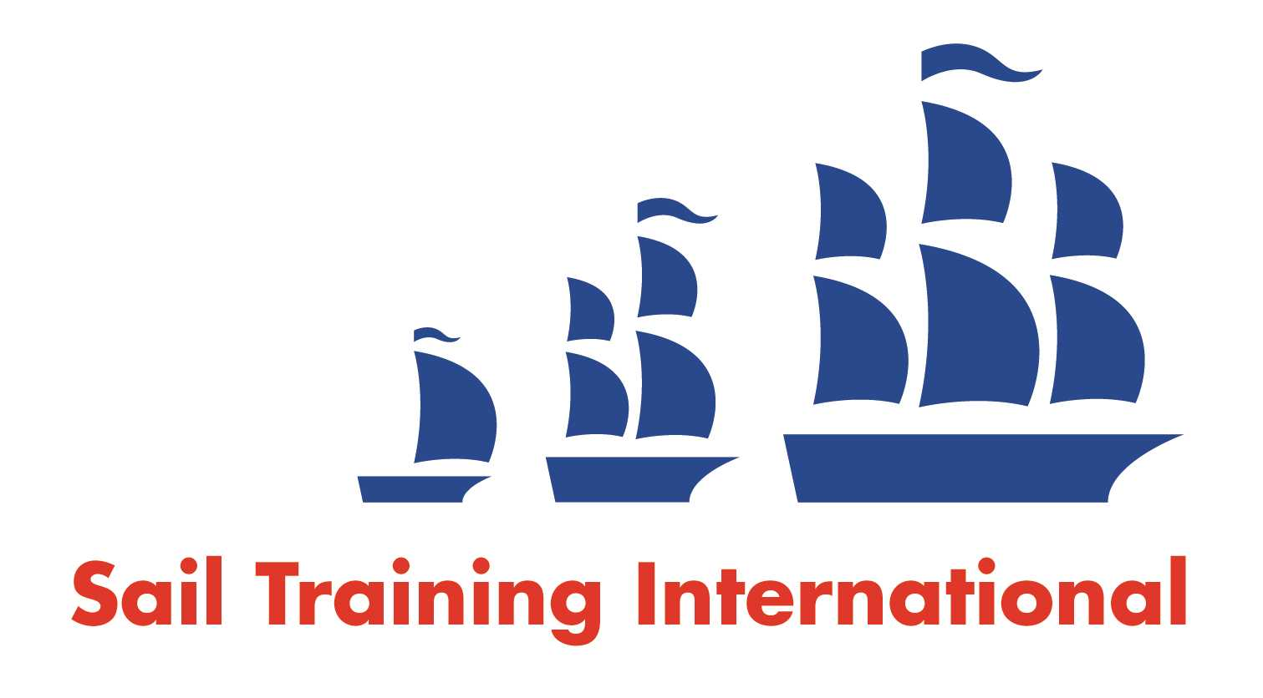
Sail Training International Positions Sought Submission Form

Editorial Policy

- This listing facility is open to any vessel operator or organisation involved in sail training.

- STI reserves the right not to publish a listing for any reason whatsoever.

- After completing the form, email to STI (office@sailtraininginternational.org) for editorial review prior to publishing on site. You can expect your advertisement to appear within 2-3 business days.

- Your listing will be automatically removed after three months unless you indicate an earlier date. To retain a listing beyond three months, please notify STI before the end of the three month period.

Date of Posting | 08/11/2017
Name | Arthur Bouët
Position Sought | Deckhand / Mate
Location preference | Any / Worldwide
Full Time/Seasonal |  | Volunteer/Paid
Description of Position Sought  (max 100 words) | I’ve been sailing on French tall ships, since 2014, between Atlantic, Brittany & English Channel, as deckhand/officer/first mate.  I’m now looking for a English speaking job, at sea.  Experience of rigging, sailmaking, carpentry.  Smiley, dynamic!
Qualifications | STCW2010 Training - C200 UMS – Sailing specification / Medical Care 3 / GMDSS GOC / Mechanic 250kW. /
Email | Ok.couque@gmail.com
Telephone | 06.45.76.46.46

