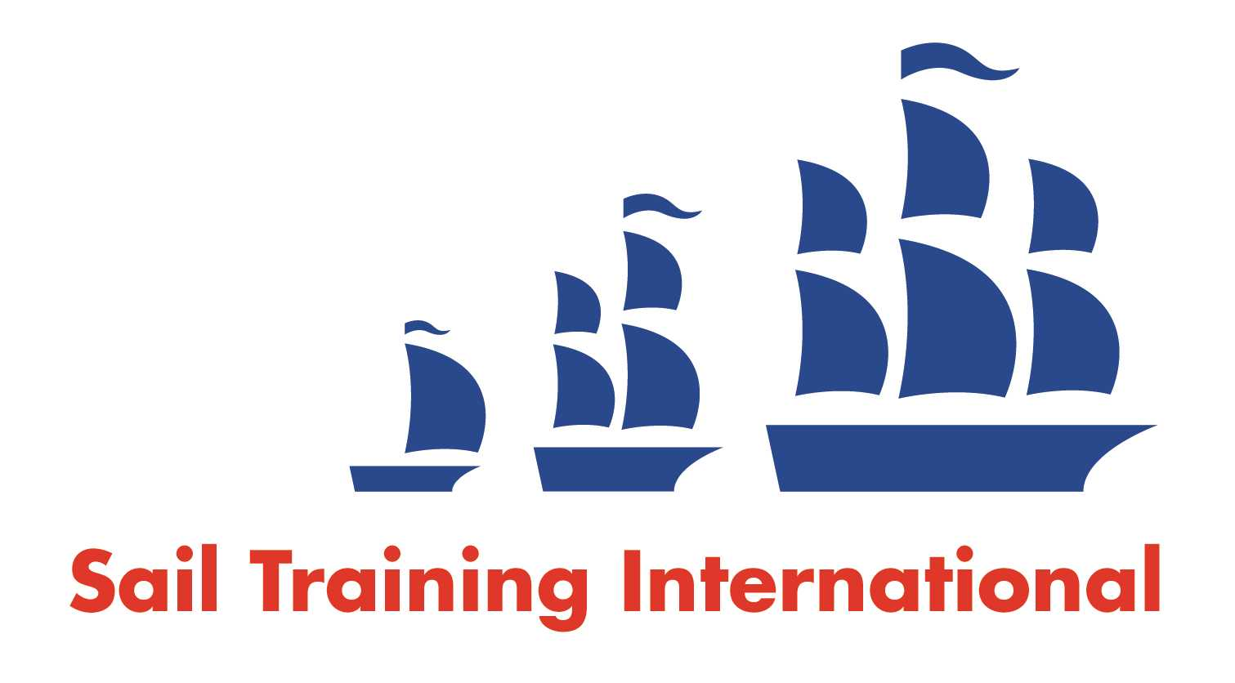
Sail Training International Paid/Volunteer Positions Submission Form

Editorial Policy

- This listing facility is free of charge but will only be accepted from sail training organisations and vessel operators that are members of their national sail training organisation or the Sail Training International Class A Tall Ships Forum.

- STI reserves the right not to publish a listing for any reason whatsoever.

- After completing the form, email to STI (sean.andrews@sailtraininginternational.org) with copy to your National Sail Training Organisation for editorial review and approval prior to publishing on site.

Date of Posting | March 23, 2016
Name of Vessel | PICTON CASTLE
Organisation Recruiting | Windward Isles Sailing Ship Company
Name of Position | Engineer
Location of Position | Lunenburg, Nova Scotia, Canada
Position is | Full Time |  | Seasonal | X
Remuneration | Paid | €/$/£  (delete as appropriate)
Description of Position | PICTON CASTLE is accepting applications for the position of Engineer for the upcoming Back-to-Back Transatlantics Voyage. The voyage begins April 18 and runs until July 31, starting and ending at Lunenburg, NS, Canada. The Engineer is responsible for all engine room and related machinery and systems, including the 690hp Burmeister & Wain Alpha diesel main engine, two Lister generators, a bank of batteries, a reverse osmosis watermaker, AC and DC powered freezers, and other electrical and plumbing systems. Must have STCW Basic Safety Training and experience working with diesel engines. Please apply by sending an email with your CV.
Person to Contact | Maggie Ostler
Organisation’s website: | Picton-castle.com
Email | info@picton-castle.com
Telephone | +1 902 634 9984
Fax | +1 902 634 9985
Closing Date for applications | Until filled

